# **Name: Abdurrahman Qureshi**

# **Roll No: 210451**

Practical No: 28 & 29 & 30

1. **Design a simple windows form for accepting the details of Student. Using the connected architecture of ADO.NET, perform following operations: Insert, Search, Update, Delete records.**

**CODE:**

Imports System.Data.OleDb

Public Class Form1

Public con As OleDbConnection

Public cmd As OleDbCommand

Public cmd2 As OleDbCommand

Public adp As OleDbDataAdapter

Public dt As New DataTable

Dim GAD_MP_Testing_Connection_str As String = "Provider=Microsoft.ACE.OLEDB.12.0;Data Source=C:\Users\Gold Roger\Documents\stud.mdb;"

Dim connection As New OleDbConnection(GAD_MP_Testing_Connection_str)

Dim com As New OleDb.OleDbCommand("Select * from Table1", connection)

Dim da As New OleDb.OleDbDataAdapter(com)

Dim ds As New DataSet

Dim dt1 As New DataTable

Private Sub Button1_Click(sender As Object, e As EventArgs) Handles Button1.Click

If TextBox1.Text = "" Then

MsgBox("Enter RollnoElse

con = New OleDbConnection("Provider=Microsoft.ACE.OLEDB.12.0;Data Source=C:\Users\Gold Roger\Documents\stud.mdb;")

con.Open()

cmd = con.CreateCommand

cmd.CommandText = "select * from Table1 where rno=" & TextBox1.Text & ""

adp = New OleDbDataAdapter(cmd)

adp.Fill(dt)

If dt.Rows.Count() > Then

TextBox2.Text = dt.Rows(0)(1).ToString

TextBox3.Text = dt.Rows(0)(2).ToString

TextBox4.Text = dt.Rows(0)(3).ToString

End IfEnd If

con.Close()

End Sub Private Sub Button2_Click(sender As Object, e As EventArgs) Handles Button3.Click

con = New OleDbConnection("Provider=Microsoft.ACE.OLEDB.12.0;Data Source=C:\Users\Gold Roger\Documents\stud.mdb;")

con.Open()

cmd = con.CreateCommand

cmd.CommandText = "insert into Table1(name,gender,rollno,phnnum)values(' " + TextBox1.Text + "',' " + TextBox2.Text + "',' " + TextBox3.Text + "',' " + TextBox4.Text + "')"

cmd.ExecuteNonQuery()

MsgBox("Inserted")

con.Close()

End Sub Private Sub Button3_Click(sender As Object, e As EventArgs) Handles Button5.Click

TextBox1.Text = ""

TextBox2.Text = ""

TextBox3.Text = ""

TextBox4.Text = ""

End Sub Private Sub Button4_Click(sender As Object, e As EventArgs) Handles Button2.Click

If TextBox1.Text = "" Then

MsgBox("Enter rollno") Else

con = New OleDbConnection("Provider=Microsoft.ACE.OLEDB.12.0;Data Source=C:\Users\Gold Roger\Documents\stud.mdb;Initial Catalog=gad_pracs;IntegratedSecurity=True")

con.Open()

cmd = con.CreateCommand

cmd.CommandText = "delete from Table1 where rno=" & TextBox1.Text & ""

cmd.ExecuteNonQuery()

MsgBox("Deleted")

con.Close()

End If

End Sub Private Sub Button5_Click(sender As Object, e As EventArgs) Handles Button1.Click

If TextBox1.Text = "" Then

MsgBox("Enter rollno")

Else

con = New OleDbConnection("Provider=Microsoft.ACE.OLEDB.12.0;Data Source=C:\Users\Gold Roger\Documents\stud.mdb;")

con.Open()

cmd = con.CreateCommand

cmd.CommandText = "update Table1 set name= '" & TextBox2.Text & "',gender='" & TextBox3.Text & " ',rollno='" & TextBox4.Text & " 'where phnnum= '" & TextBox1.Text & "'"

cmd.ExecuteNonQuery()

MsgBox("Updated")

con.Close()

End If End Sub

Private Sub Form1_Load(sender As Object, e As EventArgs) Handles MyBase.Load

connection.Open()

da.Fill(dt1)

'da.Fill(ds)

DataGridView1.DataSource = dt1

connection.Close()

End Sub Private Sub Button4_Click_1(sender As Object, e As EventArgs) Handles Button4.Click

Me.Close()

End Sub End Clas

**OUTPUT:**

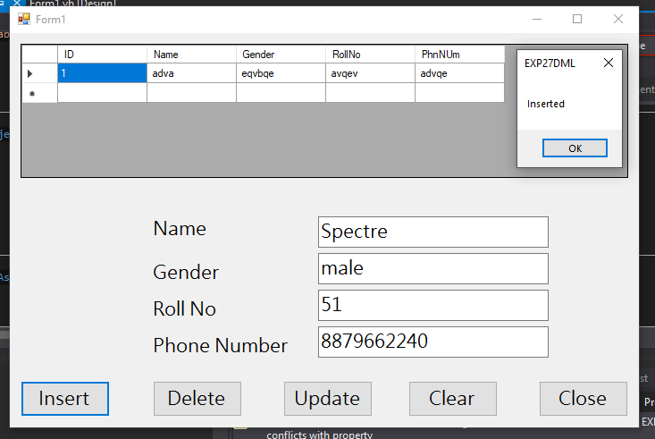

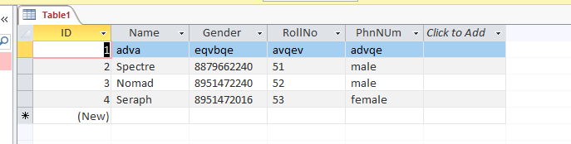

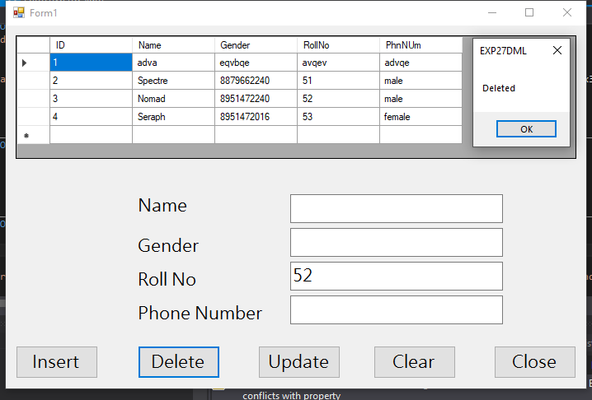

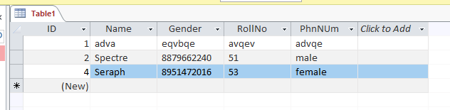

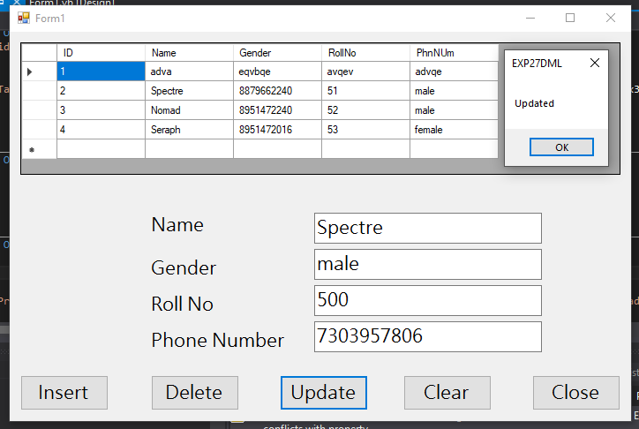

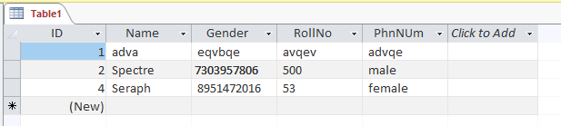

1. **Design windows application for accounting record & display it using data binding use appropriate database**

**CODE**

Imports System.Data.OleDb

Public Class Form1

Public con As OleDbConnection

Public cmd As OleDbCommand

Public adp As OleDbDataAdapter

Public ds As New DataSet

Dim con1 = New OleDbConnection("Provider=Microsoft.ACE.OLEDB.12.0;Data Source=C:\Users\Gold Roger\Documents\FoodHub_DB.mdb;")

Dim com As New OleDb.OleDbCommand("Select * from FoodHubUsers", con1)

Dim da As New OleDb.OleDbDataAdapter(com)

Dim ds1 As New DataSet

Dim dt As New DataTable

Private Sub Form1_Load(sender As Object, e As EventArgs) Handles MyBase.Load

con = New OleDbConnection("Provider=Microsoft.ACE.OLEDB.12.0;Data Source=C:\Users\Gold Roger\Documents\FoodHub_DB.mdb;")

con.Open()

cmd = con.CreateCommand

cmd.CommandText = "select * from FoodHubUsers"

adp = New OleDbDataAdapter(cmd)

adp.Fill(ds, "FoodHubUsers")

ComboBox1.DataSource = ds.Tables("FoodHubUsers")

ComboBox2.DataSource = ds.Tables("FoodHubUsers")

ComboBox3.DataSource = ds.Tables("FoodHubUsers")

ComboBox4.DataSource = ds.Tables("FoodHubUsers")

ComboBox1.DisplayMember = "UserName"

ComboBox2.DisplayMember = "EmailID"

ComboBox3.DisplayMember = "PhoneNumber"

ComboBox4.DisplayMember = "Password"

con1.Open() da.Fill(dt)

'da.Fill(ds)

DataGridView1.DataSource =dt

con1.Close()

End Sub

End Class

**OUTPUT:**

